The Microsoft Office Accessibility Checker
Microsoft Word and PowerPoint have a built-in Accessibility Checker that can help you verify the accessibility compliance of documents and presentations. The Accessibility Checker scans the file and looks for content that could be a potential barrier or issue for people with disabilities.

To Activate the Accessibility Checker:
You’ll access the Accessibility Checker the same way in both Word and PowerPoint.
- Click the File tab to access Backstage View.
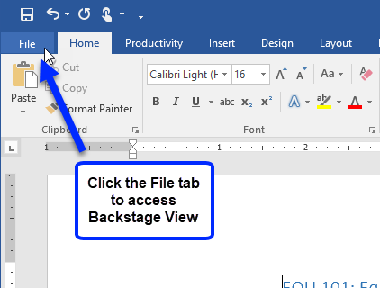
- Click the Check for Issues drop-down menu and select Check Accessibility.
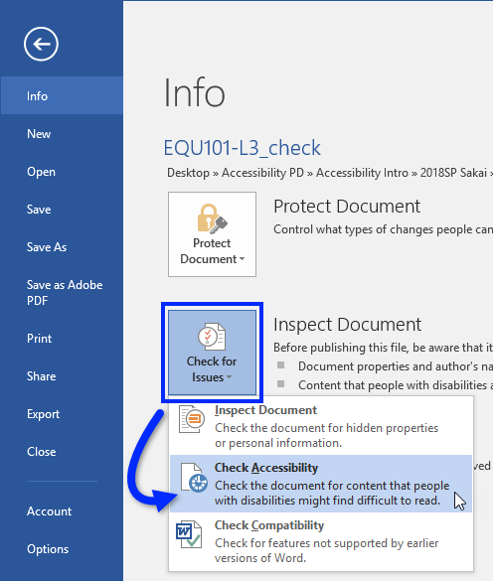
- On the right side of the screen, the Accessibility Checker pane appears. It displays the Accessibility Checker’s Inspection Results.
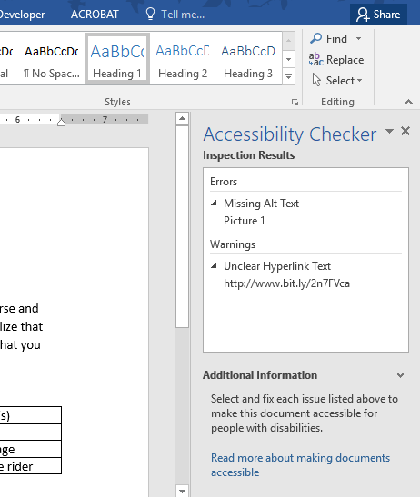

Please Make a Note
If the Accessibility Checker is unable to check the document/presentation, try saving it with a *.docx (document) or *.pptx (presentation) file extension (click File, and then Save As), and then try activating the Accessibility Checker again.
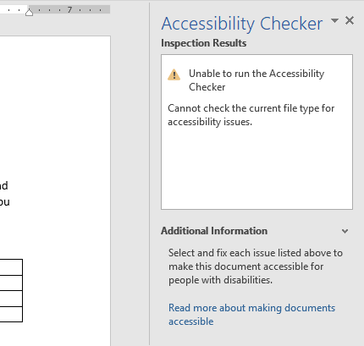

Addressing Accessibility Issues
When the Accessibility Checker detects one or more accessibility issues, a list of Errors and Warnings appears in its Inspection Results.
- Content tagged with an Error may be impossible for people with disabilities to understand (for example, an image without an alternative text or slides that do not have titles).
- Content tagged with a Warning may be difficult for people with disabilities to understand (for example, unclear hyperlink text).
In addition to displaying potential barriers for people with disabilities, the Accessibility Checker also provides information on how to fix each of the accessibility issues it detects.

To Display Information about How to Fix an Accessibility Issue:
From the Accessibility Checker’s Inspection Results, select an issue. The inaccessible content becomes highlighted in the document (or presentation), and information about how to fix the issue appears under the Additional Information area of the Accessibility Checker pane.
