Making Images Accessible
Images can perform a variety of useful tasks, such as supplementing your lecture content or providing thoughtful imagery for discussion. To make them available to students unable to see them, they need text representation, called alternative text. This handout provides instructions on adding alternative text to an image in Word, PowerPoint, and Sakai.

Adding Alternative Text to an Image in Word
- After inserting an image, right-click the image and select Format Picture from the menu that appears.
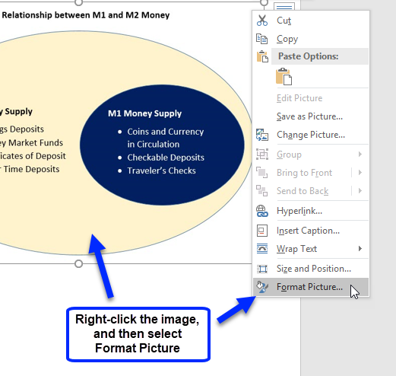
- A pane appears on the right. Click the Layout & Properties icon.
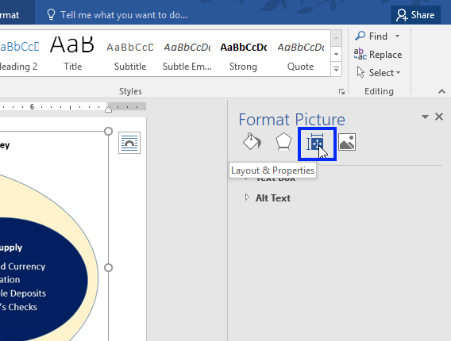
- Click Alt Text and type the image’s text representation in the Description field.
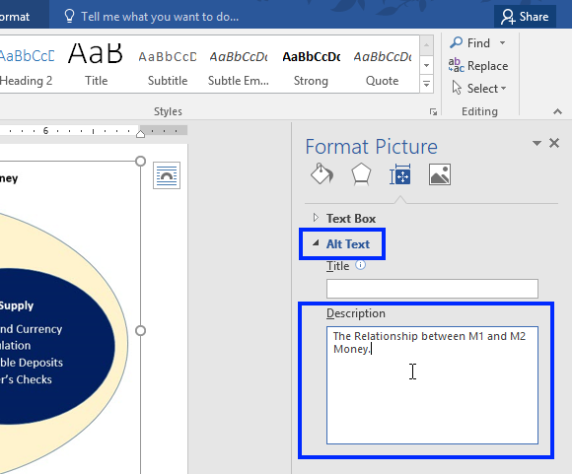
- Close the Format Picture pane by clicking the X in the upper-right corner.
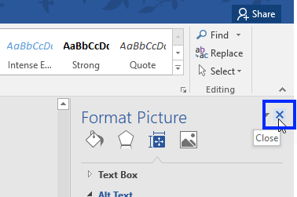

Adding Alternative Text to an Image in PowerPoint
- After inserting an image, right-click the image and select Format Picture from the menu that appears.
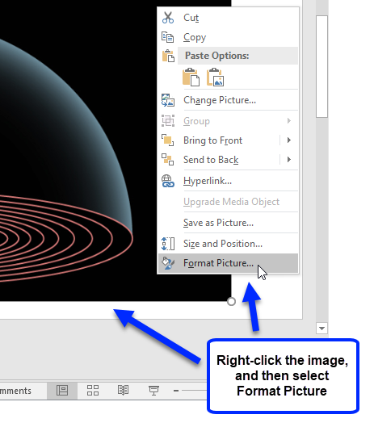
- A pane appears on the right. Click the Size & Properties icon.
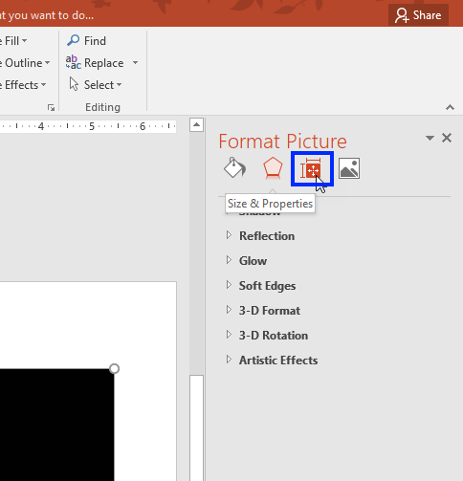
- Click Alt Text and type the image’s text representation in the Description field.
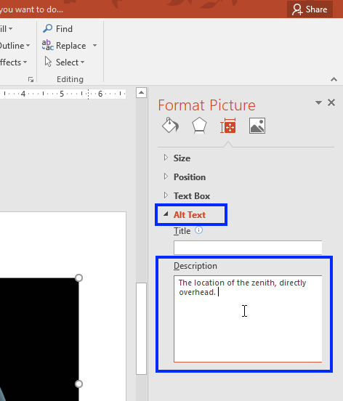
- Close the Format Picture pane by clicking the X in the upper-right corner.
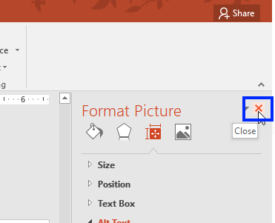

Adding Alternative Text to an Image in Sakai
In Sakai, there are two ways an instructor can insert an image. Below are instructions for adding alternate text for each method.

Method 1: Embedded Image in Lessons
- From within Lessons, click Add Content and select Embed content on page.
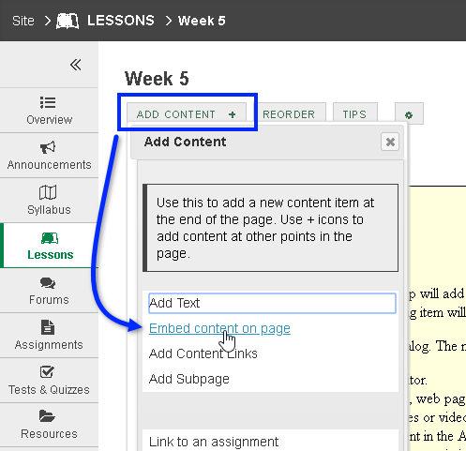
- A dialog box appears. Click Choose Files, or click Or select existing files from Resources.
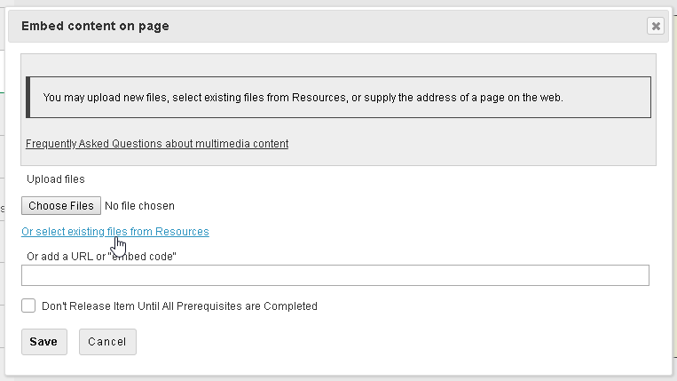
- Locate and select the file you wish to embed.
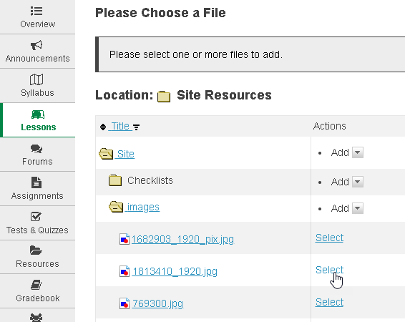
- The image appears in Sakai. To access the image’s alternative text field, click Edit content item.
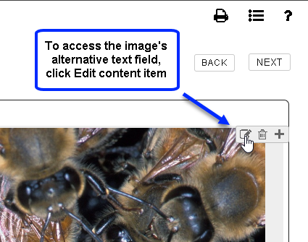
- Type the image’s alternative text in the alt text field. In the Alt Text field, type the image’s text representation. Click Save.
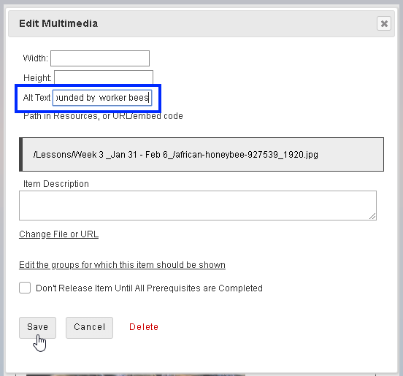

Method 2: Use the Text Editor Toolbar
- From the text editor’s tool bar, click the Image icon.
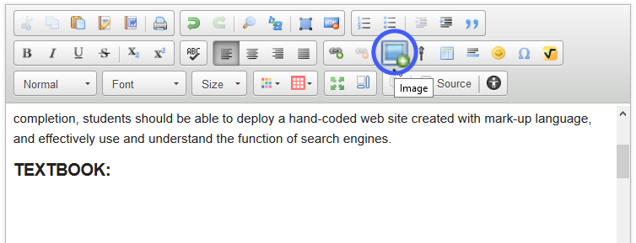
- A dialog box appears. Click Browse Server to locate and select the image.
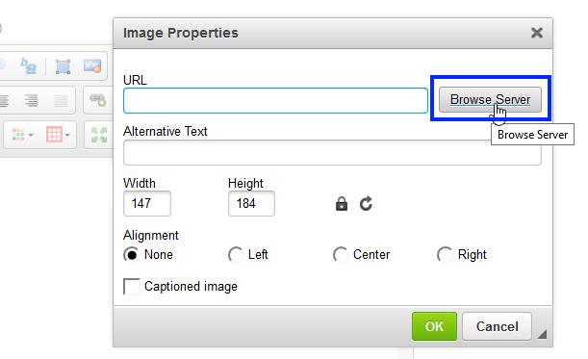
- In the Alternative Text field, type the image’s text representation. Click OK.
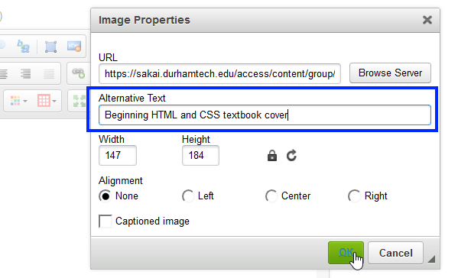

Determining When to Use a Long Description
Often, a long description will be required for more complex or educational graphics. When the information portrayed in an image requires more text representation than what can be provided in its succinct alternative text, a long description will provide the means by which you can further describe an image. All students can benefit from having access to the long description; they will have access to the information you have decided is important for them to know about the image.

Adding a Long Description in Word
Type the long description near the image. For example, as a paragraph after the image. Then type the location of the long description in the image’s alt text field (the Description field) so the student using assistive technology will know where to find it.
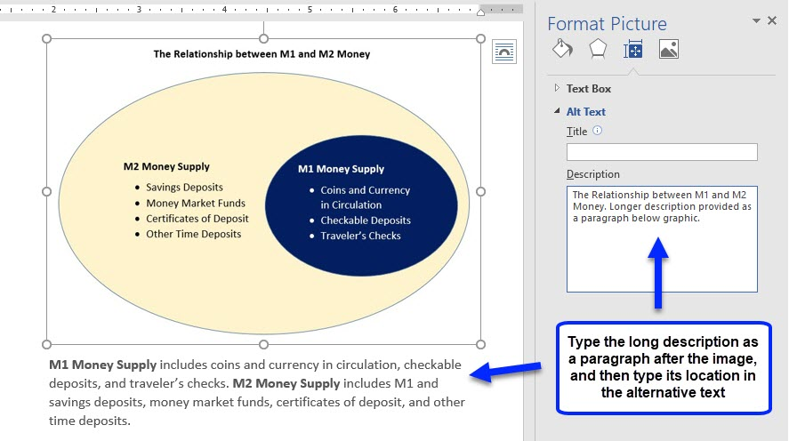

Adding a Long Description in PowerPoint
Depending on the amount of text needed for the long description, it can be typed in the Notes area of a slide or included as a list on the slide itself. (If a paragraph is needed, it’s best to type the long description in the Notes area.) Then type the location of the long description in the image’s alt text field (the Description field) so the student using a screen reader will know where to find it.
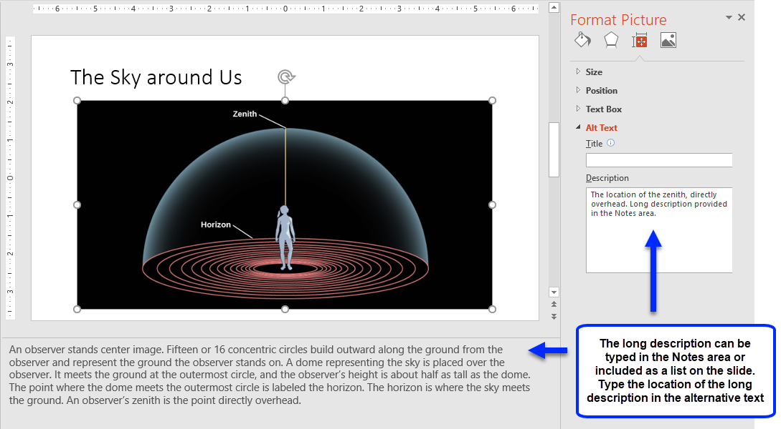

Adding a Long Description in Sakai

Method 1: Embedded Image in Lessons
Click Edit content item and type the long description in the Item Description field. The long description will appear as sentences under the image in Lessons.
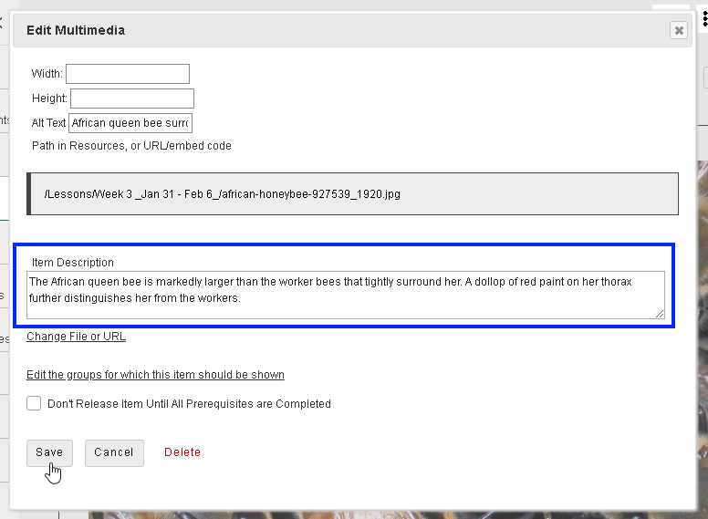

Method 2: Using the Text Editor toolbar
Type the long description after the image (or hyperlink to a document that contains the long description). Then type the location of the long description in the image’s Alternative Text field so the student using a screen reader will know where to find it.
