Captioned Videos
Captions provide hearing impaired students access to a video's audio content. They are a text version of spoken words, and they usually appear at the bottom of the screen. There are many sources from which you can obtain videos (YouTube, Durham Tech’s library, publisher content, and others). This handout provides step-by-step instructions for locating captioned videos on YouTube.

To Locate Captioned Videos on YouTube:
- Visit www.youtube.com, and then enter the content you’d like to search for into YouTube’s search bar. Click the magnifying glass.
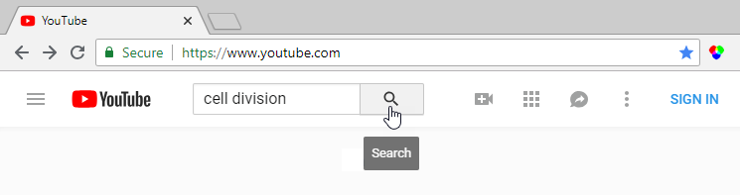
- Both uncaptioned and captioned results will appear. To filter for captioned videos, click Filter.
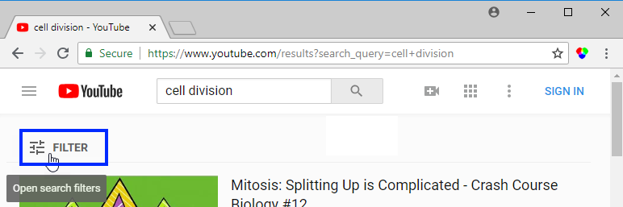
- A table of filters appears. In the Features column, click Subtitles/CC.
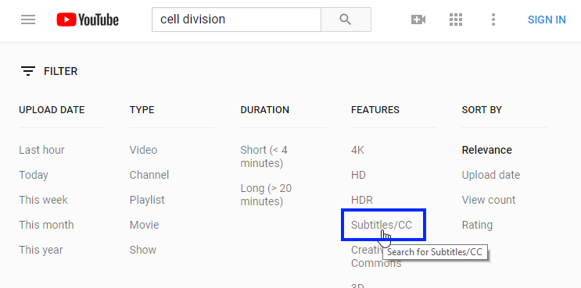
- The filtered results appear. Click a title to select the desired video.
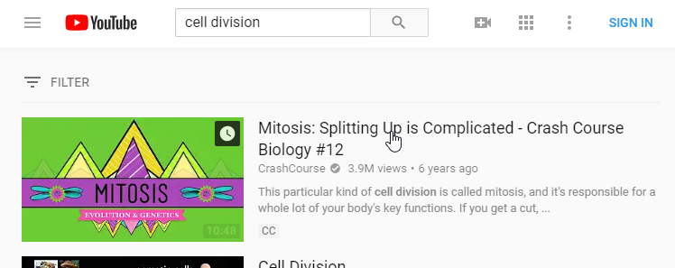
- Review the accuracy of the captions by playing the video and clicking CC to turn on the captions.
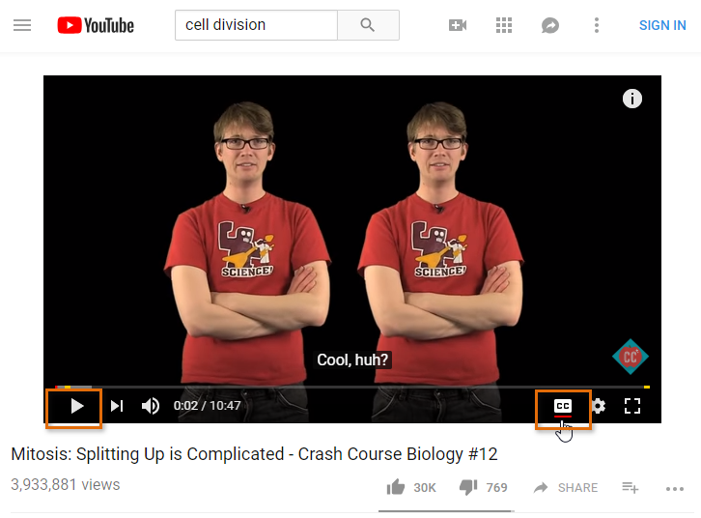

Additional Resources
- Durham Tech Library’s Streaming Video Collections

