Adding a Content Placeholder to a Slide Layout Template
PowerPoint’s Slide Master View allows you to add content placeholders to PowerPoint’s existing slide layout templates. Before adding a placeholder to a slide layout template, it’s recommended that you duplicate the slide layout template that you want to modify. This will prevent you from losing the original template.

To Duplicate a Slide Layout Template and Add a Placeholder:
- In PowerPoint, click the View tab and select Slide Master.
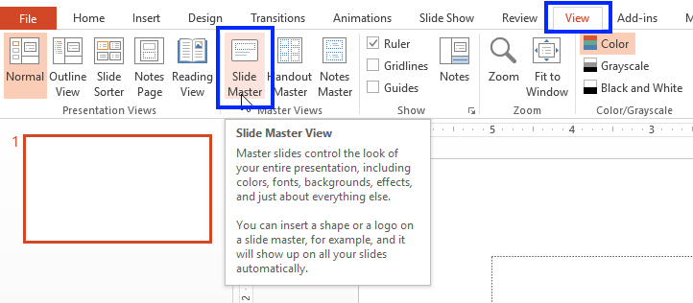
- Select the slide layout template that you want to modify. In this example, we’ve selected Two Content Layout. To duplicate the layout, right-click and select Duplicate Layout.
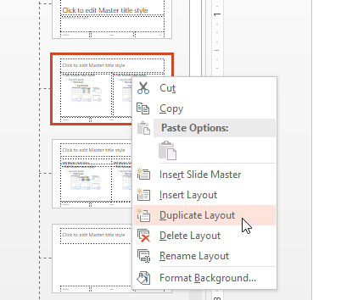
- A copy of the slide layout template appears. PowerPoint assigns a name to the template; however, if you want to rename it, right-click the slide layout template and select Rename Layout.
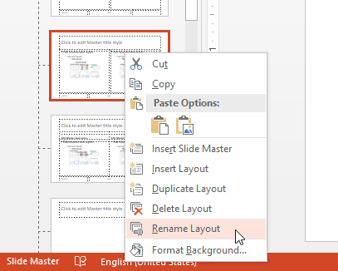
- The Rename Layout dialog box appears. Type a new name, and click Rename. (In this example, we’re creating a template with three placeholders, so we renamed it to describe the number of placeholders.
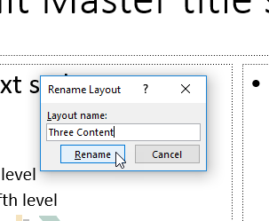
- Move or reshape the existing placeholders to the desired positions. To add a new placeholder to the slide, click Insert Placeholder and select a placeholder.
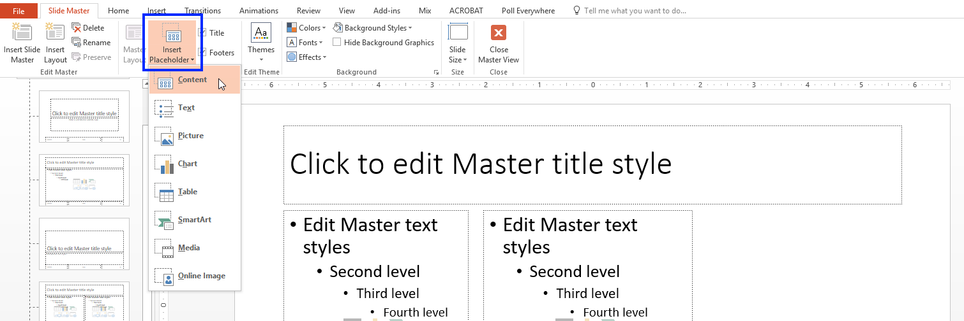
- Click, hold, and drag the mouse on the slide to create the placeholder.
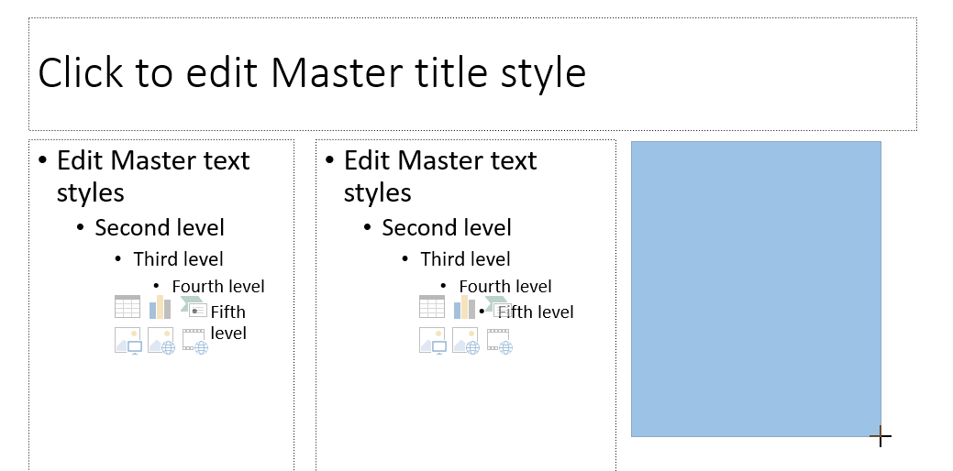
- Release the mouse, and the placeholder appears.
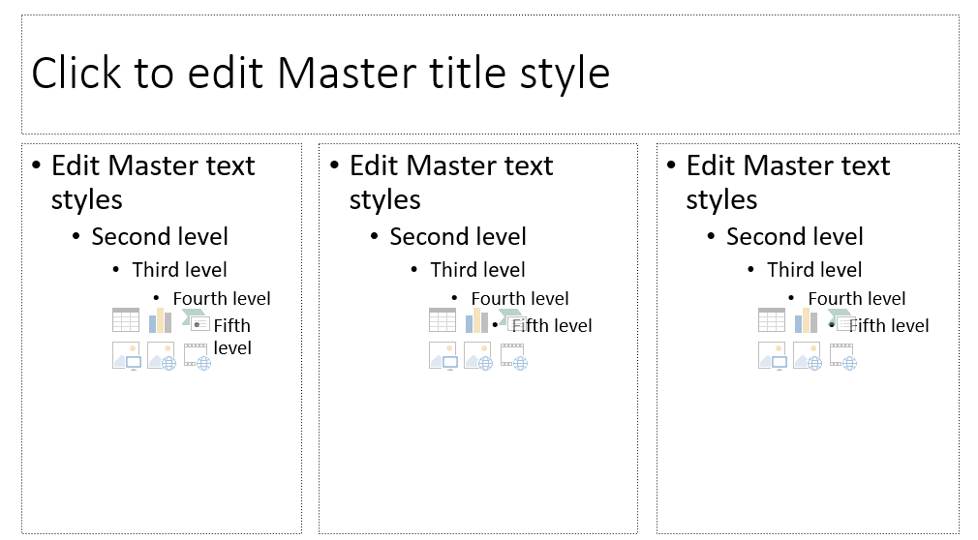
- To save your changes, click Close Master View.
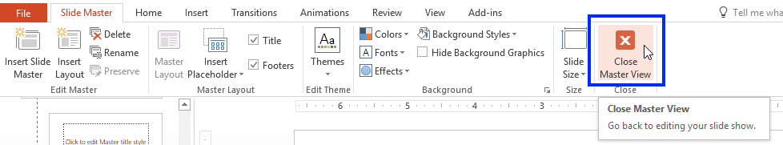
- To use the new slide layout template, click New Slide or Layout.
